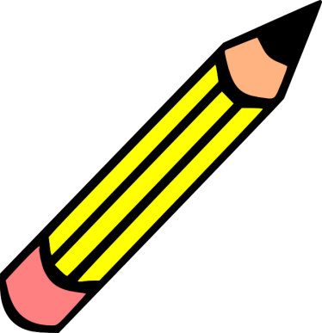
What do I annotate?
REMEMBER: Highlighters and pencils work together;
one should never be used without the other!

Characters:
- highlight characters that are important to the plot
- Draw a web of the main character, and the characters that play an important role in the story

Theme:
- Make notes of the possible themes in the story, and the text evidence that supports those themes

Conflict:
- Locate the conflict in the story, and decide what type of conflict the character is experiencing. Be sure to note if the type of conflict changes throughout the story!

Elements of Plot:
- Setting
- Climax
- Rising and falling actions

Personal Connections:
- Be sure to note when you have made a personal connection with either the story and yourself, or the story and a movie or book you have read.

Inferences and questions:
- When you finish reading, make predictions about what you think might happen next, and write down lingering questions to discuss in class or with a neighbor.

POP QUIZ: What does annotating look like in a book where no writing is allowed? __________________________

